**Team 8: Prum Soriya**

**Snorng Sreynen**

**Smart Alarm Clock Components’ List**

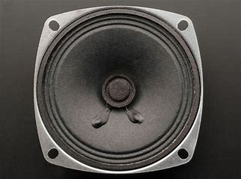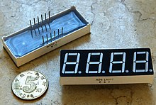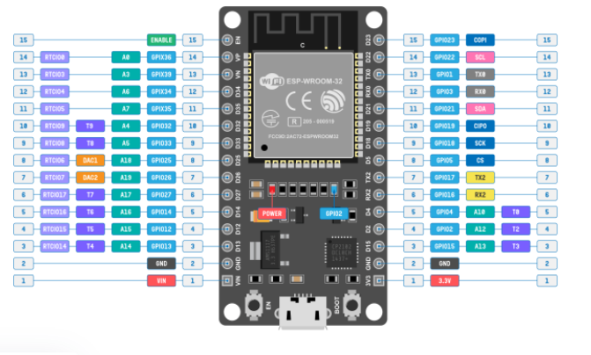

4 ohms speaker

7 segment 4 digit

ESP-Wroom-32